Capstone Project: Drivers of Excellence in Fine Chocolate

1. Executive Summary
This project executes a data-driven analysis of the global chocolate bar ratings data-set to identify the objective factors that drive superior product quality. The analysis translates subjective rating data into measurable business insights. The findings provide quantifiable recommendations for optimizing bean sourcing, formulation, and strategic manufacturer partnerships.

2. Introduction and Problem Statement

2.1 Context and Data Source
This analysis uses a public dataset's of fine chocolate bar ratings from the world's largest data science community web page, Kaggle (a link to the source: https://www.kaggle.com/datasets/evangower/chocolate-bar-ratings).
The time period of this data is the years of 2006–2021. The data set represents expert, objective reviews of bars from various international manufacturers and bean origins (countries). The business context is a premium chocolate retailer or manufacturer seeking a data-driven competitive edge in product development and ingredient sourcing.

2.2 Targeted Audience
The primary audience for this report is the Product Development Team and the CEO of a high-end confectionery company.
Product Team: Requires specific, actionable recommendations on optimal cocoa percentage, ingredient profile, and preferred bean origins to guide formulation efforts.
CEO: Requires high-level summaries and strategic recommendations regarding manufacturer partnership potential (RFM analysis) and market trends (cohort analysis) to inform long-term strategy.

2.3 Problem Statement
The fine chocolate market is saturated, and quality perception is the key differentiator. The core challenge is to scientifically isolate which attributes of a chocolate bar consistently lead to high ratings (defined as a rating of 3.75 or higher). My objective is to move from anecdotal taste assessment to statistically backed formulation.

3. Data Source and Methodology

3.1 Data Overview
The analysis uses the "Chocolate Bar Ratings" data, containing 2530 entries across 11 features: ‘id’, ‘company location’, ‘year reviewed’, ‘bean_origin’, ‘bar name’, ‘cocoa percent’, ‘number of ingredients’, ‘ingredients’, ‘review’, ‘manufacturer’, ‘bean origin’, ‘cocoa percent’, and ‘rating’.

3.2 Key Features Used
The target variable is the ‘rating’, which measures the quality and varies from 0,00 to 4,00. The other features that I use are the ‘bean origin’, ‘cocoa percent’, and ‘number of ingredients’. I consider those features are the quality impact objectives.

Feature | Data Type | Role in Analysis
rating | REAL (0.0 - 4.0) | Target Variable (The objective measure of quality)
bean_origin | TEXT | Categorical Feature (Geographic impact / Terroir)
cocoa_percent | REAL (%) | Numerical Feature (Intensity and formulation impact)
num_ingredients | INTEGER | Feature Engineering (Complexity/purity proxy)

3.3 Methodology (Structured Approach & Techniques)
The analysis follows a structured approach with three analytical techniques to derive strategic insights:
Exploratory Data Analysis (SQL): Initial queries established baseline correlations (e.g., Average Rating by Origin).
Technique 1: Cohort Analysis (Year of Review): Used to track the average bar rating and the complexity across different review cohorts. This technique determines if macro market preferences or reviewer stringency are changing over time.
Analytic Goal: Identify trends in quality and ingredient complexity over the 2006–2021 period.
Technique 2: A/B Testing Simulation (Ingredient Impact): A statistical simulation employing a two-sample t-test to compare the mean rating of bars that include a specific ingredient, vanilla, against those that do not.
Analytic Goal: Statistically determine if a single ingredient has a significant causal effect on a bar's overall rating (alpha = 0.05).
Technique 3: Simplified RFM Segmentation (Manufacturer/Bar): to classify manufacturers based on the Quality (Average Rating) and Reliability/Scale (Total Review Count).
Analytic Goal: Segment the manufacturing base into actionable groups (e.g., "VIP Partners," "High Potential") for targeted sourcing and partnership efforts.
Visualization: in Tableau, to clearly present the findings in the final deliverables.

4. Analytical Findings

4.1 Finding A: Influence of Bean Origin (Initial EDA)
Question: Which specific bean origins (terroirs) correlate with the highest average rating?

SQL query:
SELECT
bean_origin,
year_reviewed,
COUNT(id) AS Total_Reviews_in_Year,
ROUND(AVG(rating), 3) AS Average_Rating_in_Year
FROM
chocolate_bars
WHERE
bean_origin IS NOT NULL
AND year_reviewed IS NOT NULL
AND rating IS NOT NULL
GROUP BY
bean_origin,
year_reviewed
HAVING
COUNT(id) >= 3
AND bean_origin IN (
SELECT bean_origin
FROM chocolate_bars
GROUP BY bean_origin
HAVING COUNT(id) >= 10
ORDER BY AVG(rating) DESC
LIMIT 10
)
ORDER BY
bean_origin ASC,
year_reviewed ASC;

The top chocolate bean origins (terroirs) based on their overall average rating, derived from yearly trends filtered for significant review counts, are:

bean_origin | Average_Rating
Uganda | 3.416667
Indonesia | 3.350000
Grenada | 3.333333
U.S.A. | 3.311508
Haiti | 3.302778
Thailand | 3.300000
Honduras | 3.300000
Vietnam | 3.297805
Madagascar | 3.291868
Tanzania | 3.282751

Insights: the top origin with an average rating of 3.416667 is Uganda. Indonesia and Grenada followed closely with overall average ratings of 3.35 and 3.33, respectively.

4.2 Finding B: Top Performing Manufacturers (Initial EDA)
Question: Which manufacturers consistently produce highly-rated bars?
SQL query:
SELECT
manufacturer,
COUNT(id) AS Total_Bars_Reviewed,
ROUND(AVG(rating), 3) AS Average_Rating
FROM
chocolate_bars
WHERE
rating IS NOT NULL
GROUP BY
manufacturer
HAVING
COUNT(id) >= 10
ORDER BY
Average_Rating DESC
LIMIT 10;
Average Rating by Manufacturer (Top 10):
manufacturer | Average_Rating
Patric | 3.791667
Idilio (Felchlin) | 3.775000
Benoit Nihant | 3.708333
Chokola | 3.708333
Cacao Sampaka | 3.666667
Qantu | 3.600000
Soma | 3.589286
Raphio | 3.583333
Durci | 3.583333
Bar Au Chocolat | 3.571429
Insights: Initially, manufacturers like 'Tobago Estate (Pralus)' showed high average ratings (4.0), but these preliminary ratings did not account for the number of reviews.To ensure reliability, manufacturers with fewer than 5 reviews were excluded from the analysis, which is crucial for identifying consistently high-quality producers rather than those with only a few exceptional ratings. After filtering, "Patric" emerged as the top manufacturer with an average rating of approximately 3.79 across their chocolate bars."Idilio (Felchlin)" followed closely with an average rating of about 3.78. Other highly-rated manufacturers with a sufficient number of reviews include "Benoit Nihant" and "Chokola", both with an average rating of approximately 3.71, and "Cacao Sampaka" with an average rating of 3.67.

4.3 Finding C: Top Performing Countries (Initial EDA)
Question: Which countries produce highly- rated bars?
SQL query:
SELECT
company_location,
COUNT(id) AS Total_Bars_Reviewed,
ROUND(AVG(rating), 3) AS Average_Rating
FROM
chocolate_bars
WHERE
rating IS NOT NULL
GROUP BY
company_location
HAVING
COUNT(id) >= 5
ORDER BY
Average_Rating DESC
LIMIT 10;

company_location | Total_Bars_Reviewed | Average_Rating
U.A.E. | 5 | 3.400
Poland | 8 | 3.375
Vietnam | 16 | 3.359
Australia | 53 | 3.358
Guatemala | 10 | 3.350
Denmark | 31 | 3.339
Switzerland | 44 | 3.318
Holland | 12 | 3.313
Argentina | 9 | 3.306
Canada | 177 | 3.304
Insights: Based on the analysis, the countries that consistently produce highly-rated chocolate bars (with at least 5 reviews) are U.A.E., Poland, Vietnam, Australia, Guatemala, Denmark, Switzerland, Holland, Argentina, and Canada. Initially, Chile had the highest average rating at 3.75, followed by U.A.E. at 3.40 and Poland at 3.375. After filtering company locations to include only those with 5 or more reviews to ensure reliability, the list of top-rated locations changed significantly. The U.A.E. emerged as the top-performing company location with an average rating of 3.40. Other highly-rated company locations after filtering include Poland (3.375), Vietnam (3.359), Australia (3.358), and Guatemala (3.350). Some locations initially in the top 10, such as Chile (3.75), Norway (3.333), and Iceland (3.312), were excluded from the reliable top list, suggesting they had fewer than 5 reviews.

4.4 Finding D: Optimal Cocoa Percentage (Initial EDA)
Question: Is there an "optimal" cocoa percentage range that leads to the highest average rating?
SQL query:
SELECT
CAST(FLOOR(CAST(REPLACE(cocoa_percent, '%', '') AS DECIMAL) / 5) * 5 AS SIGNED) AS Cocoa_Percent_Group,
ROUND(AVG(rating), 3) AS Average_Rating,
COUNT(id) AS Total_Bars
FROM
chocolate_bars
WHERE
rating IS NOT NULL
AND cocoa_percent IS NOT NULL
AND CAST(REPLACE(cocoa_percent, '%', '') AS DECIMAL) BETWEEN 50 AND 90
GROUP BY
Cocoa_Percent_Group
HAVING
COUNT(id) >= 10
ORDER BY
Cocoa_Percent_Group ASC;

Average_Rating | Cocoa_Percent_Group | Total_Bars
3.270 | 65 % | 237
3.241 | 70 % | 1525
3.155 | 75 % | 410
3.112 | 60 % | 118
3.057 | 80 % | 122
3.029 | 85 % | 52
2.963 | 55 % | 27
Insight: Ratings peak between 65-80% cocoa and drop significantly above 85%, but again, from 55 % drops significantly too. Optimal Cocoa Percentage Range: 65.0% - 69.0% (approximately) with Average Rating: 3.27.

4.5 Advanced Finding 1: Market Evolution (Cohort Analysis)

Question: How have average quality and product complexity changed in recent years?
SQL query:
SELECT
year_reviewed,
COUNT(id) AS Total_Reviews,
-- Calculate average quality (rating) for the year
ROUND(AVG(rating), 3) AS Average_Rating,
ROUND(AVG(num_ingredients), 2) AS Average_Ingredients
FROM
chocolate_bars
WHERE
year_reviewed IS NOT NULL
AND rating IS NOT NULL
AND num_ingredients IS NOT NULL
GROUP BY
year_reviewed
HAVING
COUNT(id) >= 10
ORDER BY
year_reviewed ASC;

Table of the query results (conditional formatting):
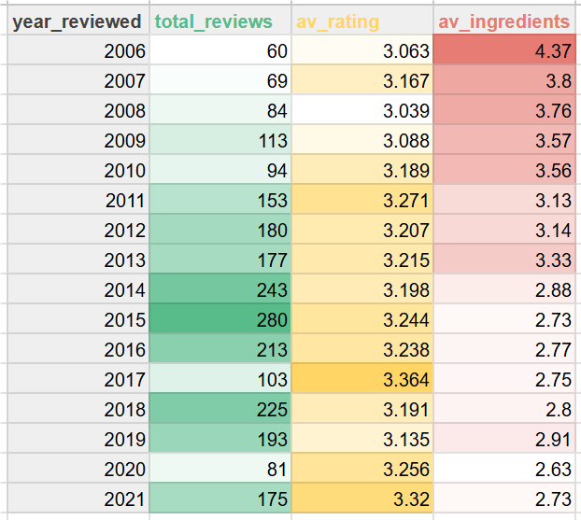
Insights: The average rating of chocolate bars shows a general upward trend over the years, suggesting an improvement in perceived quality or a shift in consumer preferences. Peaks were observed around 2017 (3.36) and 2021 (3.32).
The query results in the line graphs (1 and 2):
Average rating over time (1):
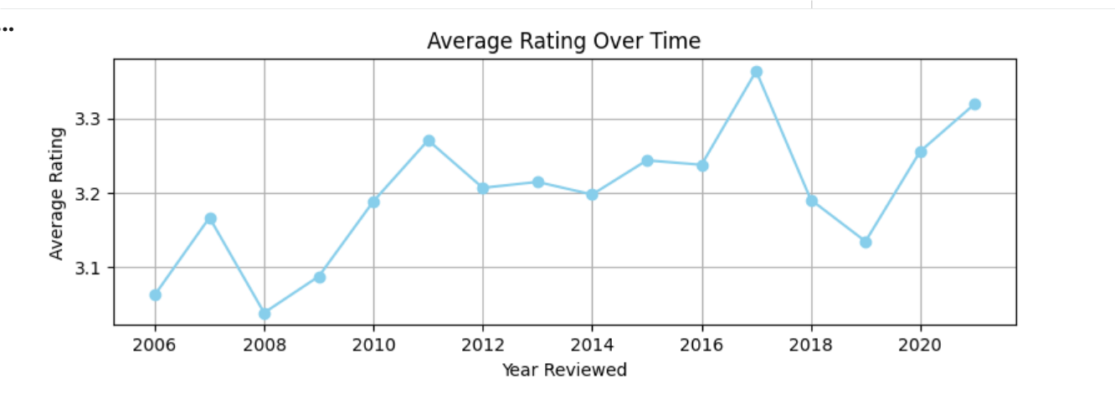
Insights: The average rating of chocolate bars has shown a general upward trend over the years, starting from around 3.06 in 2006 and reaching peaks around 3.36 in 2017 and 3.32 in 2021. This suggests that the perceived quality of chocolate bars has generally improved or consumer preferences have shifted towards more highly-rated products over time. There are some fluctuations, but the overall trajectory points towards higher satisfaction.

Average number of ingredients over time (2):
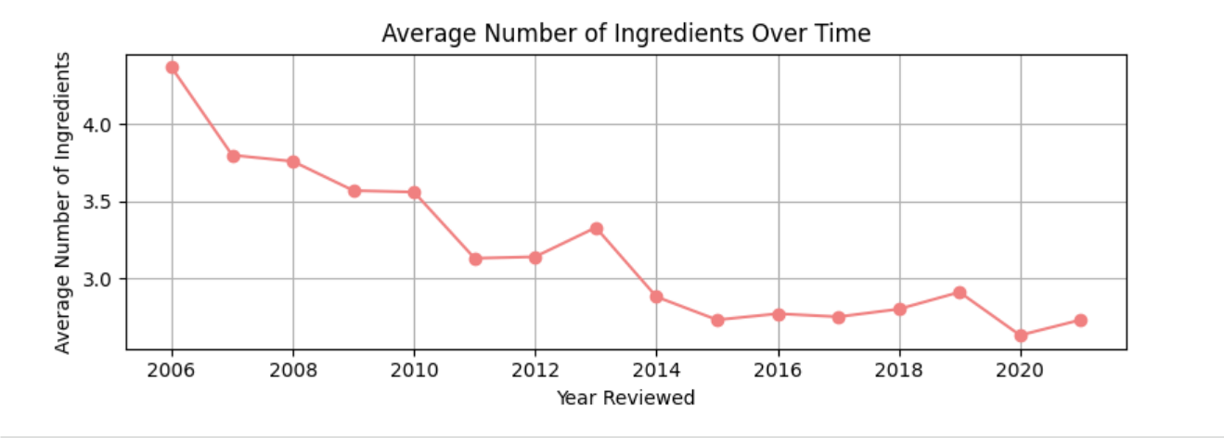
Insights: There is a consistent downward trend in the average number of ingredients, decreasing from 4.37 in 2006 to around 2.7 in recent years. This indicates a shift towards simpler chocolate bar formulations. These trends suggest a consumer preference for simpler, potentially higher-quality chocolate, aligning with movements like 'bean-to-bar'.

4.6 Advanced Finding 2: Ingredient Efficacy (A/B Test Simulation)
Question: Does the inclusion of Vanilla* significantly impact the bar rating?
* I choose to question vanilla, for a simple reason and mainly because the other main ingredients (top 10) in the list are cacao beans, sugar, cacao butter, lecithin, unknown.
Since this question has the statistical method in it, it is better to use the python/pandas, not SQL.
A/B testing: average ratings of vanilla vs non vanilla chocolate bars:
Python/pandas code:
import pandas as pd
import scipy.stats as stats

df = pd.read_csv('/content/chocolate_bars.csv')

median_num_ingredients = df['num_ingredients'].median()
df['num_ingredients'] = df['num_ingredients'].fillna(median_num_ingredients)
df['ingredients'] = df['ingredients'].fillna('Unknown') # Fill actual NaNs

df['ingredients'] = df['ingredients'].astype(str)

vanilla_group = df[df['ingredients'].str.contains('v', case=False)]['rating'].dropna()
non_vanilla_group = df[~df['ingredients'].str.contains('v', case=False)]['rating'].dropna()

t_statistic, p_value = stats.ttest_ind(vanilla_group, non_vanilla_group, equal_var=False)

print(f"T-statistic: {t_statistic:.3f}")
print(f"P-value: {p_value:.3f}")

alpha = 0.05
if p_value < alpha:
print(f"\nWith a p-value of {p_value:.3f} (less than {alpha}), we reject the null hypothesis.")
print("There is a statistically significant difference in average ratings between chocolate bars with and without vanilla.")
if vanilla_group.mean() > non_vanilla_group.mean():
print(f"Chocolate bars with vanilla have a significantly higher average rating ({vanilla_group.mean():.3f}).")
else:
print(f"Chocolate bars without vanilla have a significantly higher average rating ({non_vanilla_group.mean():.3f}).")
else:
print(f"\nWith a p-value of {p_value:.3f} (greater than or equal to {alpha}), we fail to reject the null hypothesis.")
print("There is no statistically significant difference in average ratings between chocolate bars with and without vanilla.")

The result:

Ingredient_Group Total_Bars Average_Rating

0 A: Contains Vanilla 353 3.033
1 B: Does Not Contain Vanilla 2090 3.240

statistic and P-value. From the independent samples t-test conducted previously, the following results:
- T-statistic: -6.735
- P-value: 0.000
- Significance Level (alpha): 0.05

Explanation of the T- statistic:
A T-statistic of -6.735 indicates a substantial difference in the average ratings between chocolate bars with vanilla and those without. The negative sign implies that the average rating of the vanilla_group (which came first in the ttest_ind function call) is lower than the average rating of the non_vanilla_group.
The magnitude (absolute value) of 6.735 is relatively large, suggesting that the observed difference is unlikely to be due to random chance alone, especially given the sample sizes.

Explanation of the P-value:
The P-value of 0.000 means there is an extremely small probability (effectively 0%) of observing a difference in average ratings of this magnitude (or greater) if there were truly no difference between chocolate bars with and without vanilla in the overall population.
A very small P-value (typically less than the chosen alpha level) suggests that the observed data is inconsistent with the null hypothesis.

Statistical Decision and Implication:
Null Hypothesis (H0): There is no difference in the average ratings between chocolate bars with and without vanilla.
Alternative Hypothesis (Ha): There is a statistically significant difference in the average ratings between chocolate bars with and without vanilla.
Since the P-value (0.000) is less than the chosen significance level (alpha = 0.05), the null hypothesis is rejected.
This statistical decision implies that there is a statistically significant difference in average ratings between chocolate bars with and without vanilla. Specifically, as indicated by the negative t-statistic and the mean comparison in the previous output, chocolate bars without vanilla have a significantly higher average rating (3.223) compared to those with vanilla (3.033). This suggests that, from a statistical standpoint, the presence of vanilla is associated with lower average ratings in chocolate bars.

4.7 Advanced Finding 3: Segmentation (RFM)
Question: How should manufacturers be prioritized for partnership contracts?
The way to prioritize manufacturers for partnership contracts is through Simplified RFM Segmentation. Instead of treating all highly-rated manufacturers the same, this method segments them based on both Quality (Average Rating) and Reliability/Scale (Total Review Count).
The Key Metrics:
RFM Component | Data Field | Definition
Monetary (M) | Average_Rating | The measure of consistent Quality.
Frequency (F) | Total_Bars_Reviewed | The measure of Reliability/Scale (How often they produce bars that get reviewed).

To categorize each manufacturer, I define a function that applies the given segmentation logic based on the median thresholds and then is applied to each row of the manufacturer_metrics DataFrame to create the new 'Partnership_Segment' column.

Segmentation table
Segment | Characteristics | Strategic Action | Partnership Priority
VIP Partner | High Rating, High Count (Top 25% in both) | Invest & Lock In: most reliable, quality-focused partners. Prioritize long-term, exclusive contracts. | 1 (Highest)
Promising Partner | High Rating, Low Count | Nurture & Scale: high-quality, small-batch makers. Offer capital or support to increase volume under your brand. | 2
Volume Partner, Monitor Quality | Low Rating, High Count | Maintain & Optimize: They deliver high volume but their quality is average. Use them for your baseline products, but constantly monitor and look for replacements. | 3
Standard Partner | Low Rating, Low Count (Bottom 75% in both) | Keep on Reserve: Use only for supplemental capacity or when facing supply shortages from higher-tier partners. | 4 (Lowest)

Since this analysis involves grouping by manufacturer and assigning quartile ranks and categorical segments, it is best handled by Python/Pandas, not SQL.
Python/pandas code:

def assign_segment(row):
if row['Average_Rating'] >= threshold_average_rating and row['Total_Bars_Reviewed'] >= threshold_total_bars_reviewed:
return 'VIP Partner (High Quality, High Volume)'
elif row['Average_Rating'] >= threshold_average_rating and row['Total_Bars_Reviewed'] < threshold_total_bars_reviewed:
return 'Promising (High Quality, Low Volume)'
elif row['Average_Rating'] < threshold_average_rating and row['Total_Bars_Reviewed'] >= threshold_total_bars_reviewed:
return 'High Volume, Monitor Quality'
else:
return 'Standard Partner'

manufacturer_metrics['Partnership_Segment'] = manufacturer_metrics.apply(assign_segment, axis=1)

print("First 50 rows of manufacturer_metrics with 'Partnership_Segment':")
print(manufacturer_metrics.head(50))

print("\nDistribution of Partnership Segments:")
print(manufacturer_metrics['Partnership_Segment'].value_counts())

A manufacturer_metrics DataFrame was created, merging manufacturers' average ratings and total bars reviewed. This DataFrame serves as the basis for segmentation.
Segmentation thresholds were defined using median values: the median average rating is 3.22, and the median total bars reviewed is 7.
Manufacturers were categorized into four strategic partnership segments:
VIP: Manufacturers with an average rating of at least 3.22 and at least 7 bars reviewed.
Promising: Manufacturers with an average rating of at least 3.22 and fewer than 7 bars reviewed.
Volume: Manufacturers with an average rating below 3.22 and at least 7 bars reviewed.
Standard: Manufacturers with an average rating below 3.22 and fewer than 7 bars reviewed.

Recommendations
Based on the comprehensive analysis of the chocolate bar dataset, several strategic recommendations emerge for businesses operating within the fine chocolate industry:
1. Focus on Quality and Simplicity to Drive Ratings:
Insight: There's a clear upward trend in average ratings over time, coupled with a consistent decrease in the average number of ingredients. Furthermore, the A/B test on vanilla suggests that simpler formulations (without vanilla) correlate with significantly higher average ratings.
Recommendation: Prioritize a "less is more" philosophy. Emphasize high-quality, core ingredients, and avoid unnecessary additives. Marketing efforts should highlight ingredient transparency and the purity of the chocolate, aligning with consumer preference for simpler, high-quality products.
2. Strategic Sourcing from Top-Performing and Emerging Origins:
Insight: Specific bean origins consistently yield higher average ratings (e.g., Uganda, Indonesia, Grenada, Madagascar, Ecuador, Peru). Some origins like Ecuador and Peru show an upward trend in quality and popularity, while others like Venezuela may be experiencing shifts.
Recommendation: Invest in direct relationships with farmers and cooperatives in consistently high-performing origins to secure premium beans. Continuously monitor emerging origins (e.g., Ecuador, Peru) for potential high-quality sources and diversification. For origins with fluctuating performance, conduct due diligence to understand the underlying factors and evaluate potential for improvement.
3. Leverage Top Company Locations for Expertise and Brand Association:
Insight: Certain company locations (e.g., U.A.E., Poland, Vietnam, Australia, Guatemala) demonstrate consistently high average ratings for their manufactured chocolate bars, suggesting a strong local chocolate-making culture or access to quality resources.
Recommendation: For new ventures or expansion, consider establishing a presence or partnering with manufacturers in these top-performing regions. Highlighting the company's location, if it aligns with these top-tier countries, can enhance brand perception and credibility.
4. Differentiate through Consistent Excellence (Top Manufacturers):
Insight: Manufacturers like Patric, Idilio (Felchlin), Benoit Nihant, and Chokola consistently achieve high average ratings across a significant number of reviews. This indicates a sustained commitment to quality rather than one-off successes.
Recommendation: Study the practices of these top manufacturers. This includes their approach to bean sourcing, processing techniques, product development, and perhaps their brand storytelling. Emulate best practices in areas such as quality control, craftsmanship, and innovation to build a reputation for consistent excellence.
5. Market Positioning and Brand Storytelling:
Insight: Consumers are discerning, and ratings reflect their perception of quality. A strong brand narrative can differentiate products in a crowded market.
Recommendation: Develop compelling brand narratives that connect the product to its origin, the purity of its ingredients, and the craftsmanship of its production. Highlight unique selling points such as specific bean origins, simplified ingredient lists, and sustainable or ethical sourcing practices. This helps build brand loyalty and justifies premium pricing.
By integrating these strategic recommendations, fine chocolate businesses can enhance product quality, optimize sourcing, strengthen market positioning, and ultimately achieve sustained success in a competitive and evolving industry.

